Assignment 7.4 - Capstone Plan TDD (Loan App)

Technical Design Document

|  |  |
| --- | --- |
| **Author** | DeVonte’ Ellis |
| **Last Updated** | 05/04/2024 - 8:03:35 pm Central |
| **Version Number** | V1.0.0 |

|  |  |  |  |
| --- | --- | --- | --- |
| **Name** | **Date** | **Reason For Change** | **Version** |
| Ellis, Devonte’ | 05/03/2024 | Creation of Document | V1.0.0 |
|  |  |  |  |
|  |  |  |  |
|  |  |  |  |
|  |  |  |  |
|  |  |  |  |
|  |  |  |  |

**Table of Contents**

SECTION 1: INTRODUCTION...........................................................................................3

1.1. Purpose..............................................................................................................3

1.2. Terminology........................................................................................................3

1.3. User Personas.....................................................................................................3

1.4. Time Estimations.................................................................................................3

SECTION 2: PROCESS DESIGN.......................................................................................4

2.1. Prototypes..........................................................................................................4

2.2. ORD (Object Relational Diagram(s)......................................................................4

SECTION 3: REFERENCES..............................................................................................4

Section 1: Introduction

**1.1 - Purpose**

The purpose of the loan app is to make an accurate, user-friendly, and easy-to-use web application that can take in financial information and give users the amount that they would need, or the time it would take to pay off a loan.

**1.2 - Terminology**

|  |  |
| --- | --- |
| **Name** | **Comments** |
|  |  |
|  |  |
|  |  |

**1.3 - User Personas**



**Name:** Timothy Johnson

**Age:** 33

**From:** Seattle, Washington

**About:** Timothy is a man that loves to travel and enjoy the great outdoors. After working for a large tech company, he found that it wasn’t as fulfilling as he thought it would be when he first started. He loves technology but doesn’t love being at the beck and call of shareholders and bosses, so one day he packed up everything and bet it all on his own startup that has recently started to bear fruit.

**What do they need from app?:** Basic loan calculation ability to manage larger finances.

**How can the app provide this?:** Having quick and user-friendly options to check loan amounts of higher sizes.

**Computer skill level:** Very High

**Frequency of use:** Daily

|  |  |  |
| --- | --- | --- |
| Timothy Johnson | User Stories | Points |
|  | As a user I need the loan app to accurately provide the information that I ask for. | 21 |
|  | As a user I need the loan app to be able to handle whatever interest rate I can throw at it. | 13 |
|  | As a user I need the loan app to show the amount of interest paid | 8 |



**Name:** Samatha Simpson

**Age:** 27

**From:** Minneapolis, Minnesota

**About:** Samantha is an on-the-go businesswoman who, after graduation, managed to make it to a company she’s always dreamed of working for. Dedication and hard work quickly moved her up the ladder. She is good with her finances, yet she always had a secondary dream that she wanted to pursue. Which is to own her own motorcycle racing team. Chasing this dream led to her taking out a loan to buy a stake into a MotoGP team.

**What do they need from app?:** The ability to do quick calculations on the go.

**How can the app provide this?:** Having a user interface that is mobile friendly and easy to use on the go.

**Computer skill level:** High

**Frequency of use:** Weekly

|  |  |  |
| --- | --- | --- |
| Samantha Simpson | User Stories | Points |
|  | As a user I need the loan app to have the ability to tell me how many years I have left to pay | 13 |
|  | As a user I need the loan app to show how much my payments would be if I changed around the amounts I paid. | 8 |
|  | As a user I need the loan app to be quick and efficient. | 5 |



**Name:** Valentine, Green

**Age:** 20

**From:** Boston, Massachusetts

**About:** Valentine works hard chasing her dream of one day being an aeronautical engineer. Her brains and ability have never once been an issue. She studies just as hard as anybody out there and it has led to her getting a good selection of scholarships for college. Valentine, however, still wants to take out a small student loan to guarantee that she won’t have to worry too much about money while she’s in school.

**What do they need from app?:** The ability to check on a decent size loan.

**How can the app provide this?:** Having the ability to accurately provide loan data.

**Computer skill level:** Average

**Frequency of use:** Weekly

|  |  |  |
| --- | --- | --- |
| Valentine Green | User Stories | Points |
|  | As a user I need the loan app to calculate interest correctly | 13 |
|  | As a user I need the loan app to be user friendly | 5 |
|  | As a user I need the loan app to be easy for me to use and understand | 5 |

**1.5 - Work Estimations**

*Note: See above 1.5 points for time estimates*

**2.1 - Prototypes**

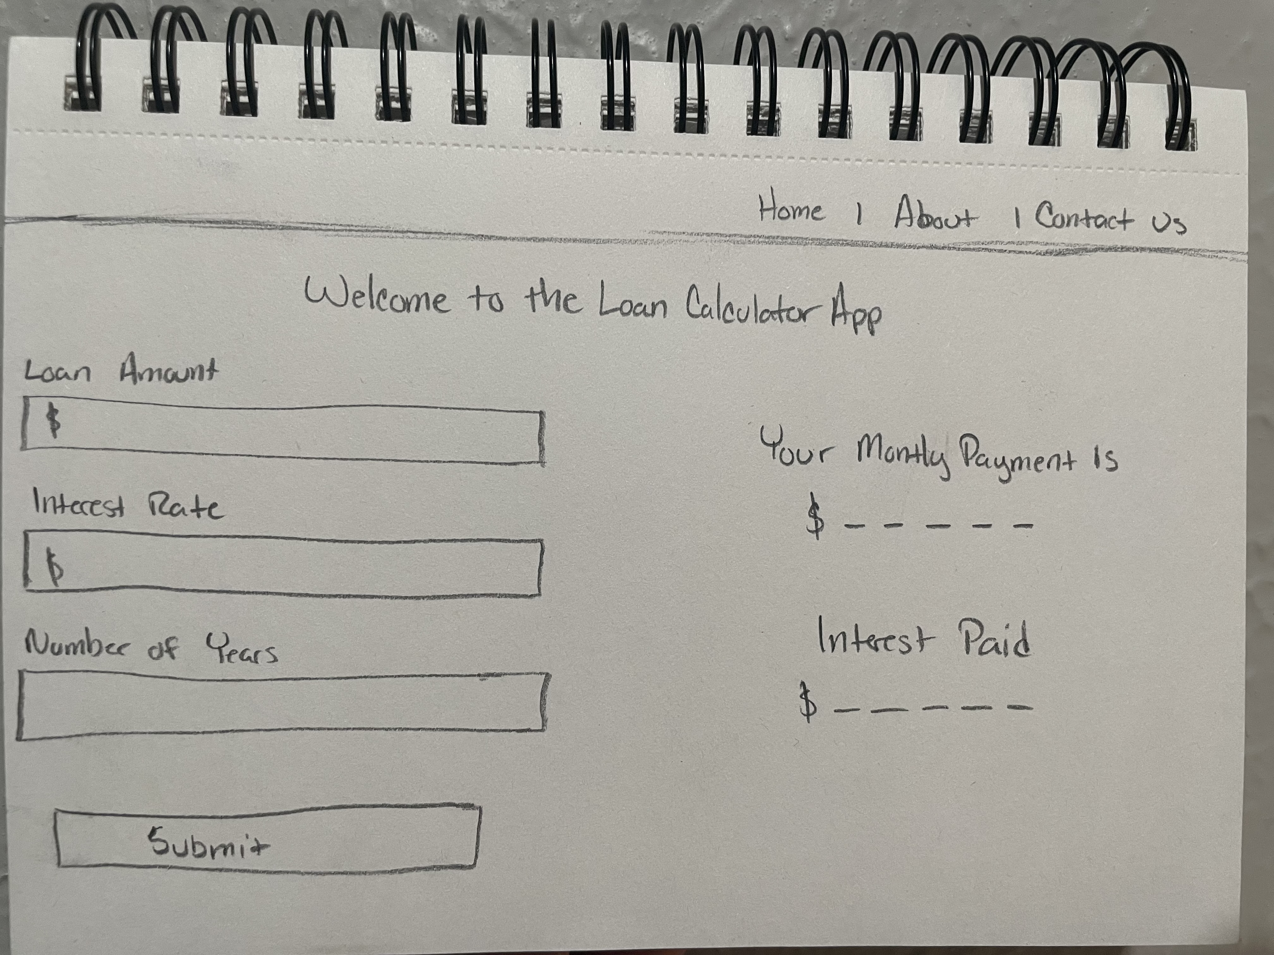

**2.2 - ORD**

